**TITLE**

A comparative study of litter size and sex composition in a large dataset of callitrichine monkeys

**RUNNING TITLE**

Litter characteristics of callitrichine monkeys

**AUTHORS**

Dakota E. McCoy1†, Brett M. Frye2[1]†, Jennifer Kotler1,3, Amanda Embury4, Judith M. Burkart5, Monika Burns6, Simon Eyre7, Peter Galbusera8, Jacqui Hooper7, Arun Idoe9, Agustín López Goya10, Jennifer Mickelberg11, Marcos Peromingo Quesada12, Miranda Stevenson13, Sara Sullivan14, Mark Warneke14, Sheila Wojciechowski14, Dominic Wormell15, David Haig1, and Suzette D. Tardif16

**SUPPORTING INFORMATION**

**SUPPLEMENTARY FIGURES**

**Supplementary Figure 1.**

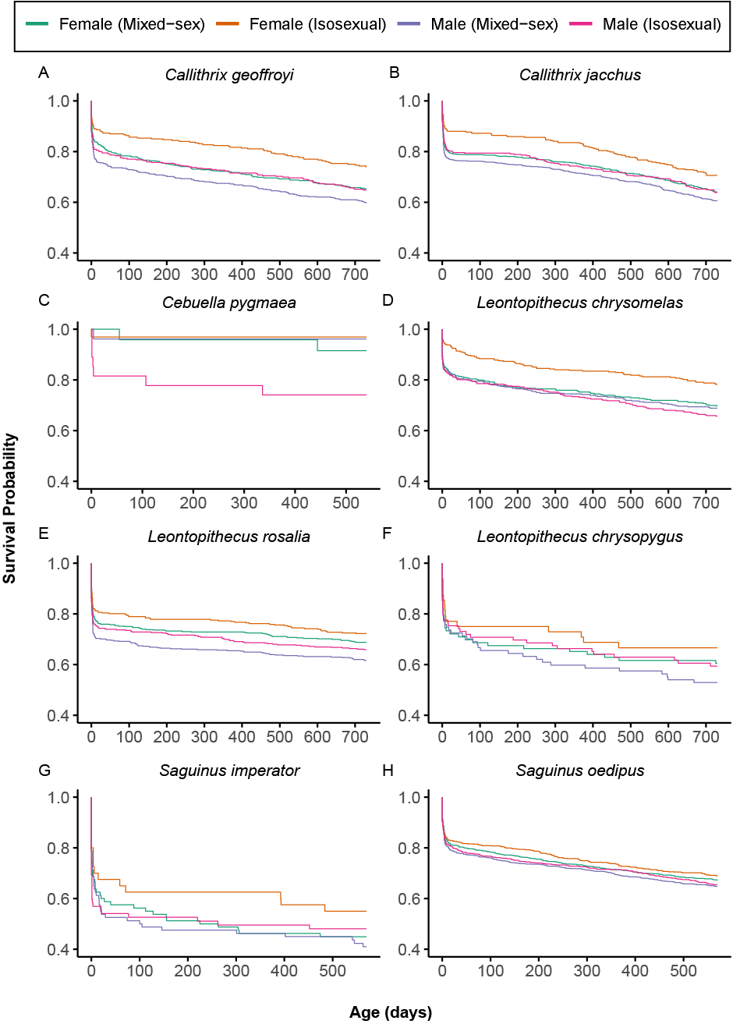

**Supplementary Figure 1.** Survivorship profiles of monkeys born into isosexual and mixed-sex litters from birth to sexual maturity for each callitrichine species.

**Supplementary Figure 2.**

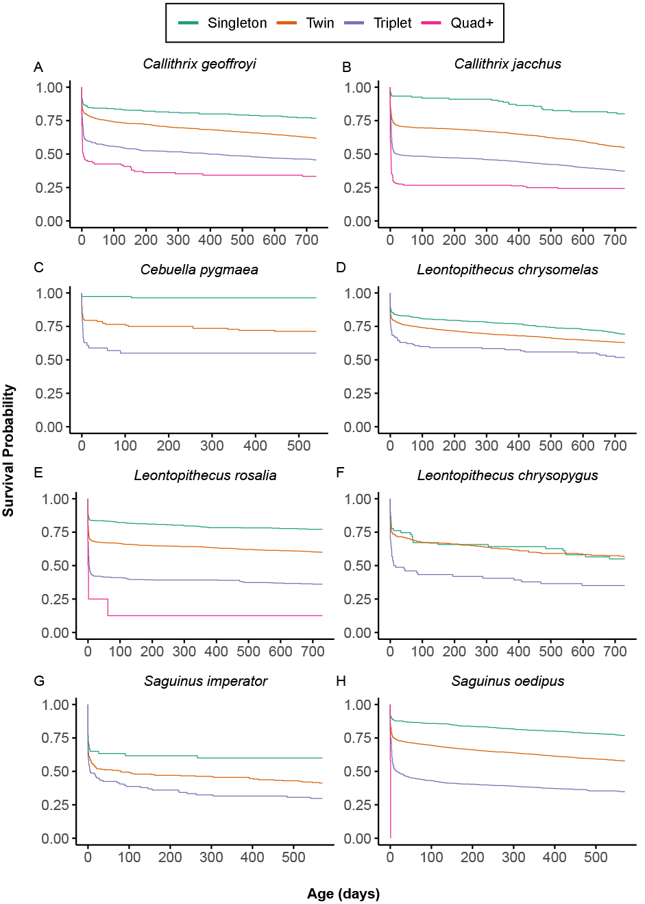

**Supplementary Figure 2.** Survivorship profiles of individuals born into singleton, twin, triplet, and quad+ litters from birth to sexual maturity for each callitrichine species.

**Supplementary Figure 3.**

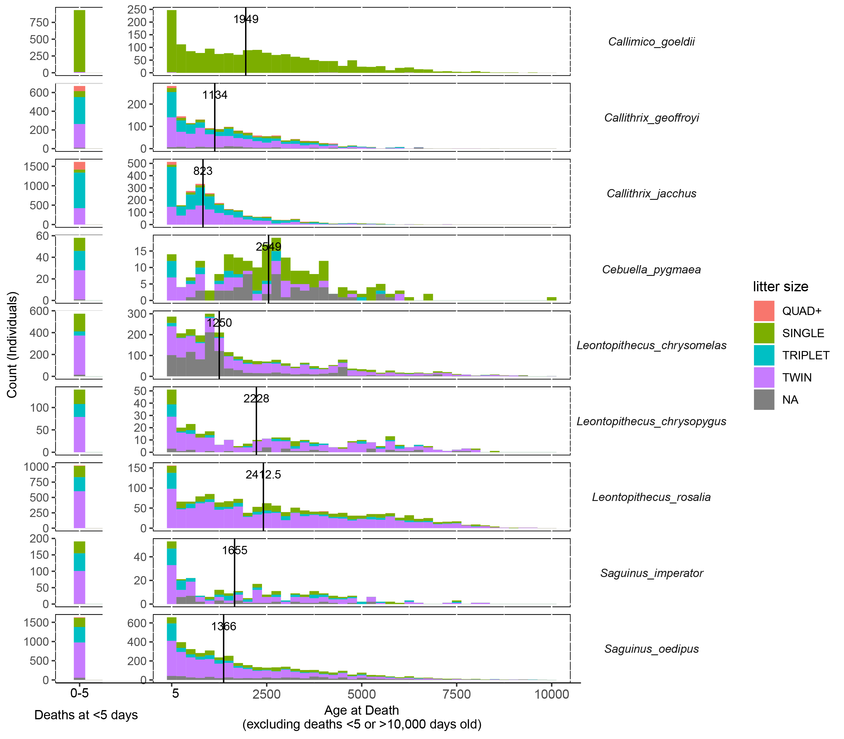

**Supplementary Figure 3: Age at death by species and litter size.**  Median ages at death (excluding ages < 5 days and > 10,000 days) are represented by vertical lines. Litter size “NA” means that we did not have data on that individual’s litter size.

**Supplementary Figure 4.**

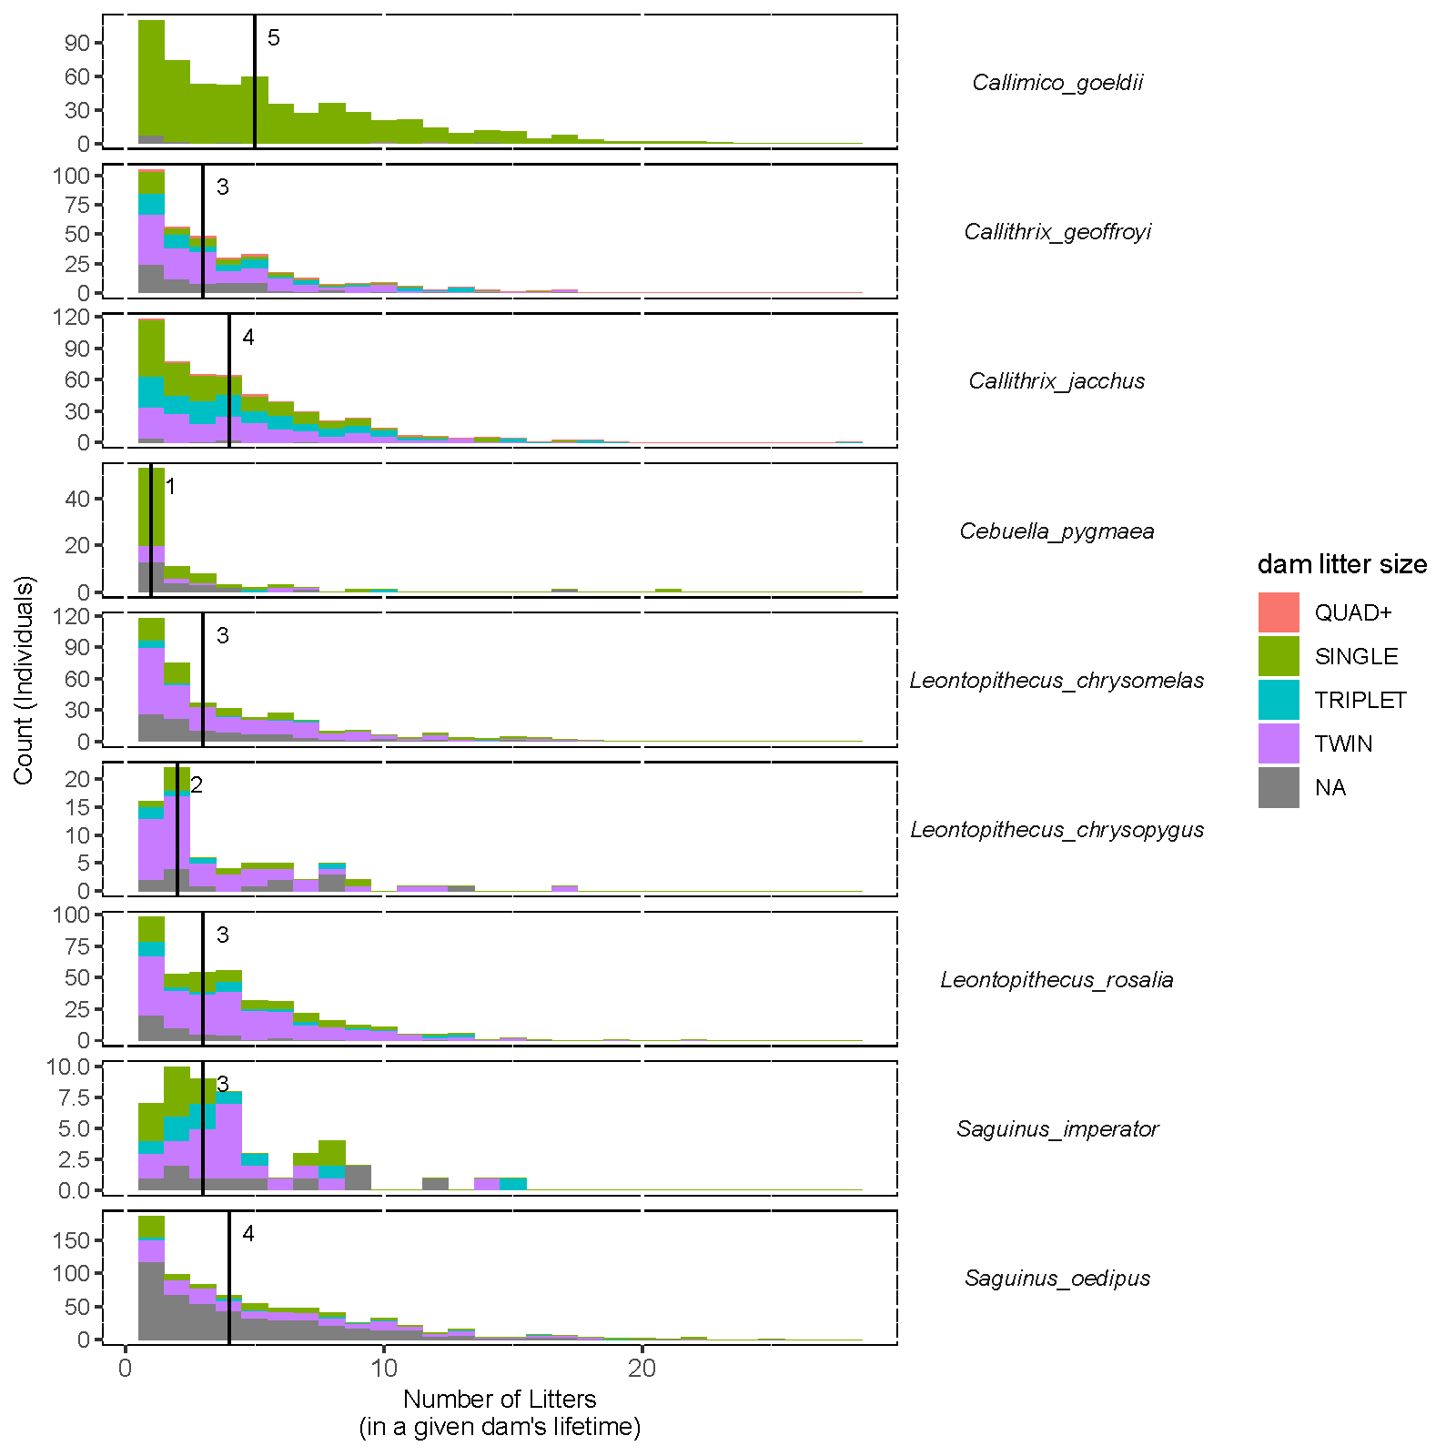**Supplementary Figure 4: Number of litters in a dam’s lifetime by species and dam’s litter size.**  Median number of litters are represented by vertical lines. Dam litter size “NA” means that we did not have data on that individual’s litter size.

**SUPPLEMENTARY TABLES**

**Supplementary Table 1**. Numbers of individuals belonging to isosexual and mixed-sex litters that constituted the sample for demographic, survival, and reproductive analyses.

|  |  |  |  |  |  |  |  |
| --- | --- | --- | --- | --- | --- | --- | --- |
| Species | Isosexual | | Mixed-Sex | | Twins | | |
|  | *Females* | *Males* | *Females* | *Males* | *FF* | *MF* | *MM* |
| *Callimico goeldii* | 2 | 2 | 2 | 2 | 2 | 4 | 2 |
| *Callithrix geoffroyi* | 323 | 389 | 499 | 519 | 280 | 566 | 316 |
| *Callithrix jacchus* | 423 | 454 | 834 | 871 | 336 | 626 | 343 |
| *Cebuella pygmaea* | 32 | 27 | 24 | 26 | 32 | 36 | 24 |
| *Leontopithecus chrysomelas* | 369 | 447 | 409 | 405 | 360 | 746 | 432 |
| *Leontopithecus chrysopygus* | 48 | 89 | 86 | 87 | 42 | 136 | 86 |
| *Leontopithecus rosalia* | 364 | 483 | 529 | 538 | 340 | 830 | 444 |
| *Saguinus imperator* | 40 | 72 | 80 | 80 | 34 | 104 | 60 |
| *Saguinus oedipus* | 721 | 822 | 932 | 944 | 688 | 1486 | 780 |
| *Overall* | **2322** | **2785** | **3395** | **3472** | **2114** | **4534** | **2487** |

**Supplementary Table 2. Timing of important life history stages for callitrichine species**. Each life history stages represents length of time (in days) for individuals to transition across ontogenetic stages from birth to maturity. Stage 1 - Period of most intensive maternal investment, in which infants are almost exclusively carried by the mother. Nursing is the exclusive source of water and nutrition. Stage 2 - Infant Period. Infant still carried the majority of the time. Carriers may include mother, father, or alloparents. Nursing still predominant source of nutrition. However, supplemental provisioning from other group members occurs. Stage 3 - Weaning. Infants are being weaned during this time. They are being supplemented by group members during this time. They are also infrequently carried during this time. Stage 4 - Juvenile Period. Time between weaning and sexual maturity. Group members are no longer provisioning the animal during this time. Stage 5 - Subadult Period. Animal has reached sexual maturity, but typically remains within the natal group. Stage 6 - Adult Period. Age at which animal animals typically begin breeding - either via acquiring the breeding position within the natal range or via emigration.

|  |  |  |  |  |  |
| --- | --- | --- | --- | --- | --- |
| Common Name(s) | Genus | Stage | Range Start (days) | Range End (days) | Citations |
| Goeldi's monkey | *Callimico* | 1 | 1 | 21 | (Dettling, 2002; Dettling & Pryce, 1999; Hardie, 1995; Heltne, Turner, & Wolhandler, 1973; Jurke & Pryce, 1994; Schradin & Anzenberger, 2001) |
| 2 | 22 | 35 |
| 3 | 36 | 120 |
| 4 | 121 | 420 |
| 5 | 421 | 480 |
| 6 | > 481 | - |
| Pygmy Marmoset | *Cebuella* | 1 | 1 | 10 | (Carlson, Ziegler, & Snowdon, 1997; Cawthon Lang, 2005b; Heymann & Soini, 1999; Soini, 1988) |
| 2 | 11 | 60 |
| 3 | 61 | 90 |
| 4 | 91 | 365 |
| 5 | 366 | 540 |
| 6 | > 541 | - |
| Emperor Tamarin, Cotton-top Tamarin, Pied Tamarin | *Saguinus* | 1 | 1 | 7 | (Cawthon Lang, 2005a; Price, 1992; Savage, Giraldo, Soto, & Snowdon, 1996; Tardif, 1984) |
| 2 | 8 | 30 |
| 3 | 31 | 90 |
| 4 | 91 | 480 |
| 5 | 481 | 570 |
| 6 | > 571 | -- |
| Geoffroy's Marmoset, Common Marmoset | *Callithrix* | 1 | 1 | 7 | (Stevenson, 1976; Stevenson & Rylands, n.d.; Tardif et al., 2008; YamamotoMaria, 1993) |
| 2 | 8 | 30 |
| 3 | 31 | 90 |
| 4 | 91 | 540 |
| 5 | 541 | 730 |
| 6 | > 731 | -- |
| Black Lion Tamarin, Golden-headed Lion Tamarin, Golden Lion Tamarin | *Leontopithecus* | 1 | 1 | 7 | (Andy J. Baker, 1991; Dietz, Baker, & Miglioretti, 1994; French, de Vleeschouwer, Bales, & Hiestermann, 2002; Tardif et al., 2002) |
| 2 | 8 | 30 |
| 3 | 31 | 90 |
| 4 | 91 | 540 |
| 5 | 541 | 730 |
| 6 | > 731 | -- |

**Supplementary Table 3.** Sex ratios within singleton, twin, and triplet litters. The sex ratios within discrete litter sizes did not diverge from the sex ratio observed in the population.

|  |  |  |  |  |  |  |  |  |  |  |  |  |  |
| --- | --- | --- | --- | --- | --- | --- | --- | --- | --- | --- | --- | --- | --- |
| Species | Singleton | | | | Twin | | | | | Triplet | | | |
|  | **Prop. Male** | ***p*** | $$χ^{2}$$ | **W** | **Prop. Male** | ***p*** | $$χ^{2}$$ | **W** | | **Prop. Male** | ***p*** | $$χ^{2}$$ | **W** |
| *Callimico goeldii* | 0.518 | 0.981 | 0.001 | <0.001 | 0.500 | 0.658 | 0.195 | 0.147 | - | | - | - | - |
| *Callithrix geoffroyi* | 0.541 | 0.597 | 0.279 | 0.032 | 0.513 | 0.407 | 0.688 | 0.024 | 0.554 | | 0.146 | 2.113 | 0.058 |
| *Callithrix jacchus* | 0.483 | 0.313 | 1.016 | 0.054 | 0.503 | 0.605 | 0.267 | 0.013 | 0.514 | | 0.727 | 0.122 | 0.009 |
| *Cebuella pygmaea* | 0.491 | 0.877 | 0.024 | 0.015 | 0.475 | 0.639 | 0.220 | 0.047 | 0.536 | | 0.692 | 0.157 | 0.075 |
| *Leontopithecus chrysomelas* | 0.524 | 0.969 | 0.002 | 0.002 | 0.524 | 0.944 | 0.005 | 0.002 | 0.524 | | 0.983 | 0.000 | 0.002 |
| *Leontopithecus chrysopygus* | 0.612 | 0.449 | 0.573 | 0.002 | 0.578 | 0.687 | 0.163 | 0.024 | 0.500 | | 0.327 | 0.961 | 0.133 |
| *Leontopithecus rosalia* | 0.562 | 0.516 | 0.422 | 0.092 | 0.539 | 0.528 | 0.398 | 0.015 | 0.563 | | 0.552 | 0.354 | 0.032 |
| *Saguinus imperator* | 0.508 | 0.523 | 0.408 | 0.031 | 0.569 | 0.545 | 0.366 | 0.042 | 0.530 | | 0.744 | 0.107 | 0.036 |
| *Saguinus oedipus* | 0.558 | 0.089 | 2.894 | 0.080 | 0.521 | 0.228 | 1.453 | 0.021 | 0.540 | | 0.653 | 0.203 | 0.018 |

**Supplementary Table 4**. Numbers of individuals born into four litter size categories by species. Mean litter size calculation, Quad+ litters were treated as equal to four individuals.

|  |  |  |  |  |  |  |
| --- | --- | --- | --- | --- | --- | --- |
| Species | Singleton | Twin | Triplet | Quad+[2]† | Mean Litter Size | Modal Litter Size |
| *Callimico goeldii* | 3449 | 16 | 0 | 0 | 1.00 | 1 |
| *Callithrix geoffroyi* | 312 | 1448 | 881 | 111 | 2.03 | 2 |
| *Callithrix jacchus* | 451 | 2004 | 2581 | 348 | 2.25 | 2 |
| *Cebuella pygmaea* | 122 | 136 | 51 | 0 | 1.49 | 1 |
| *Leontopithecus chrysomelas* | 620 | 1870 | 132 | 0 | 1.64 | 2 |
| *Leontopithecus chrysopygus* | 94 | 316 | 69 | 0 | 1.74 | 2 |
| *Leontopithecus rosalia* | 563 | 2098 | 453 | 8 | 1.77 | 2 |
| *Saguinus imperator* | 82 | 250 | 111 | 0 | 1.89 | 2 |
| *Saguinus oedipus* | 1159 | 4048 | 987 | 12 | 1.80 | 2 |
| *Overall* | **6852** | **12186** | **5265** | **479** | **1.67** | **2** |

**Supplementary Table 5.** Model objects for Cox proportional hazards regression for survivorship. Hazard ratios less than one indicate lower mortality. Hazards greater than one indicate higher mortality risk. Significant values are indicated in bold.

|  |  |  |  |  |
| --- | --- | --- | --- | --- |
|  | **Hazard Ratio** | **95% CI** | ***z* value** | ***p* value** |
| ***Callithrix geoffroyi*** |  |  |  |  |
| Litter Size | 0.540 | 0.378 - 0.772 | -3.377 | **< 0.001** |
| Litter Type | 0.860 | 0.652 - 1.134 | -1.070 | 0.284 |
| Sex | 1.235 | 1.002 - 1.522 | 1.978 | **0.048** |
| Litter Type × Sex | 1.163 | 0.817 - 1.654 | 0.840 | 0.401 |
| ***Callithrix jacchus*** |  |  |  |  |
| Litter Size | 0.586 | 0.429 - 0.801 | -3.360 | **< 0.001** |
| Litter Type | 1.074 | 0.847 - 1.362 | 0.591 | 0.555 |
| Sex | 1.121 | 0.944 - 1.332 | 1.304 | 0.192 |
| Litter Type × Sex | 1.196 | 0.888 - 1.612 | 1.177 | 0.239 |
| ***Cebuella pygmaea*** |  |  |  |  |
| Litter Size | 1.432 | 0.302 - 6.790 | 0.452 | 0.652 |
| Litter Type | 0.418 | 0.033 - 5.303 | -0.673 | 0.501 |
| Sex | 0.456 | 0.045 - 4.641 | -0.664 | 0.507 |
| Litter Type × Sex | 19.512 | 0.748 - <20.0 | 1.786 | 0.074 |
| ***Leontopithecus chrysomelas*** |  |  |  |  |
| Litter Size | 1.555 | 1.107 - 2.186 | 2.543 | **0.011** |
| Litter Type | 0.678 | 0.512 - 0.898 | -2.714 | **0.007** |
| Sex | 1.045 | 0.812 - 1.345 | 0.342 | 0.732 |
| Litter Type × Sex | 1.658 | 1.149 - 2.392 | 2.701 | **0.007** |
| ***Leontopithecus chrysopygus*** |  |  |  |  |
| Litter Size | 1.959 | 1.246 - 3.081 | 2.914 | **0.004** |
| Litter Type | 0.812 | 0.449 - 1.469 | -0.689 | 0.491 |
| Sex | 1.199 | 0.763 - 1.885 | 0.787 | 0.431 |
| Litter Type × Sex | 1.173 | 0.550 - 2.499 | 0.412 | 0.680 |
| ***Leontopithecus rosalia*** |  |  |  |  |
| Litter Size | 0.289 | 0.181 - 0.452 | -5.367 | **< 0.001** |
| Litter Type | 1.017 | 0.790 - 1.309 | 0.128 | 0.898 |
| Sex | 1.267 | 1.031 - 1.557 | 2.251 | **0.024** |
| Litter Type × Sex | 1.012 | 0.732 - 1.399 | 0.073 | 0.942 |
| ***Saguinus imperator*** |  |  |  |  |
| Litter Size | 1.276 | 0.895 - 1.820 | 1.348 | 0.178 |
| Litter Type | 0.802 | 0.465 - 1.383 | -0.793 | 0.428 |
| Sex | 1.094 | 0.735 - 1.628 | 0.441 | 0.659 |
| Litter Type × Sex | 1.241 | 0.620 - 2.485 | 0.609 | 0.542 |
| ***Saguinus oedipus*** |  |  |  |  |
| Litter Size | 0.114 | 0.091 - 0.144 | -18.549 | **< 0.001** |
| Litter Type | 1.120 | 0.912 - 1.375 | 1.077 | 0.281 |
| Sex | 1.096 | 0.970 - 1.237 | 1.475 | 0.140 |
| Litter Type × Sex | 1.026 | 0.802 - 1.313 | 0.203 | 0.839 |

**Supplementary Table 6**. *Post hoc* pairwise comparisons of Cox proportional hazards model objects (i.e., four levels of litter type: isosexual female, mixed-sex female, isosexual male, mixed-sex male) in *Leontopithecus chyrsomelas* using log-rank test. Multiple comparisons corrected using the Benjamini & Hochberg method (1995).

|  |  |  |  |  |
| --- | --- | --- | --- | --- |
|  |  | Mixed-Sex Female | Isosexual Female | Mixed-Sex Male |
| *Leontopithecus chrysomelas* | | | | |
|  | Isosexual Female | **0.007** | - | - |
|  | Mixed-sex Male | 0.778 | **0.004** | - |
|  | Isosexual Male | 0.378 | **< 0.001** | 0.485 |

**Supplementary Table 7**. *Post hoc* pairwise comparisons of Cox proportional hazards model objects (i.e., sex: male versus female) in *Callithrix geoffroyi* and *Leontopithecus rosalia* using log-rank test. Multiple comparisons corrected using the Benjamini & Hochberg method (1995).

|  |  |
| --- | --- |
| Species | *p* |
| *Callithrix geoffroyi* | **0.004** |
| *Callithrix jacchus* | - |
| *Cebuella pygmaea* | - |
| *Leontopithecus chrysomelas* | - |
| *Leontopithecus chrysopygus* | - |
| *Leontopithecus rosalia* | **0.006** |
| *Saguinus imperator* | - |
| *Saguinus oedipus* | - |

**Supplementary Table 8**. *Post hoc* pairwise comparisons of Cox proportional hazards model objects (i.e., litter size) using log-rank test. Multiple comparisons corrected using the Benjamini & Hochberg method (1995).

|  |  |  |  |  |  |
| --- | --- | --- | --- | --- | --- |
|  |  | Singleton | Twin | Triplet | Quad+ |
| *Callithrix geoffroyi* | | | | | |
|  | Singleton | - | **< 0.001** | **< 0.001** | **< 0.001** |
|  | Twin | **< 0.001** | - | **< 0.001** | **< 0.001** |
|  | Triplet | **< 0.001** | **< 0.001** | - | **0.002** |
|  | Quad+ | **< 0.001** | **< 0.001** | **< 0.001** | - |
| *Callithrix jacchus* | | | | | |
|  | Singleton | - | **< 0.001** | **< 0.001** | **< 0.001** |
|  | Twin | **< 0.001** | - | **< 0.001** | **< 0.001** |
|  | Triplet | **< 0.001** | **< 0.001** | - | **< 0.001** |
|  | Quad+ | **< 0.001** | **< 0.001** | **< 0.001** | - |
| *Cebuella pygmaea* | | | | | |
|  | Singleton | - | NA | NA | NA |
|  | Twin | NA | - | NA | NA |
|  | Triplet | NA | NA | - | NA |
|  | Quad+ | NA | NA | NA | - |
| *Leontopithecus chrysomelas* | | | | | |
|  | Singleton | - | **0.005** | **< 0.001** | NA |
|  | Twin | **0.005** | - | **0.005** | NA |
|  | Triplet | **< 0.001** | **0.005** | - | NA |
|  | Quad+ | NA | NA | NA | - |
| *Leontopithecus chrysopygus* | | | | | |
|  | Singleton | - | 0.959 | **0.018** | NA |
|  | Twin | 0.959 | - | **0.002** | NA |
|  | Triplet | **0.018** | **0.002** | - | NA |
|  | Quad+ | NA | NA | NA | - |
| *Leontopithecus rosalia* | | | | | |
|  | Singleton | - | **< 0.001** | **< 0.001** | **< 0.001** |
|  | Twin | **< 0.001** | - | **< 0.001** | **0.001** |
|  | Triplet | **< 0.001** | **< 0.001** | - | 0.094 |
|  | Quad+ | **< 0.001** | **< 0.001** | 0.094 | - |
| *Saguinus imperator* | | | | | |
|  | Singleton | - | NA | NA | NA |
|  | Twin | NA | - | NA | NA |
|  | Triplet | NA | NA | - | NA |
|  | Quad+ | NA | NA | NA | - |
| *Saguinus oedipus* | | | | | |
|  | Singleton | - | **< 0.001** | **< 0.001** | **< 0.001** |
|  | Twin | **< 0.001** | - | **< 0.001** | **< 0.001** |
|  | Triplet | **< 0.001** | **< 0.001** | - | **< 0.001** |
|  | Quad+ | **< 0.001** | **< 0.001** | **< 0.001** | - |

**Supplementary Table 9: For most species, singletons had a better reproductive performance than litterborn individuals. (A)** Singleton dams bore more offspring than expected for five species: *Callithrix geoffroyi, Callithrix jacchus, Cebuella pygmaea, Leontopithecus rosalia*, and *Saguinus oedipus*. **(B)** Singletons were overrepresented among unique dams for five species: *Callithrix geoffroyi, Callithrix jacchus, Cebuella pygmaea, Leontopithecus rosalia*, and *Saguinus oedipus*. **(C)** Singleton sires fathered more offspring than expected 7 of 8 species, with the opposite trend in *Leontopithecus chrysopygus*. **(D)** Singletons were overrepresented among unique sires for 6 of 8 species: *Callithrix geoffroyi, Callithrix jacchus, Cebuella pygmaea, Leontopithecus rosalia*, *Saguinus imperator,* and *Saguinus oedipus*. **This table refers to Figure 4.**

**(A) All Offspring: dams can be double-counted**

|  |  |  |  |  |  |  |  |  |  |  |
| --- | --- | --- | --- | --- | --- | --- | --- | --- | --- | --- |
| Species | Dam Count: Singletons | Dam Count: Litters | Female Population Count: Singletons | Female Population Count: Litters | Obs. Prop. Singletons | Exp. Prop. Singletons | p-value | X2 | Effect Size | label |
| *Callithrix geoffroyi* | 372 | 1880 | 122 | 915 | 0.17 | 0.12 | <0.001 | 49.03 | 0.15 | *** |
| *Callithrix jacchus* | 1632 | 3673 | 180 | 1550 | 0.31 | 0.10 | 0 | 2358.73 | 0.67 | *** |
| *Cebuella pygmaea* | 134 | 86 | 56 | 65 | 0.61 | 0.46 | <0.001 | 18.94 | 0.29 | *** |
| *Leontopithecus chrysomelas* | 461 | 1525 | 248 | 824 | 0.23 | 0.23 | 0.93 | 0.010 | 0 |  |
| *Leontopithecus chrysopygus* | 62 | 303 | 26 | 143 | 0.17 | 0.15 | 0.40 | 0.72 | 0.040 |  |
| *Leontopithecus rosalia* | 601 | 2268 | 190 | 946 | 0.21 | 0.17 | <0.001 | 36.73 | 0.11 | *** |
| *Saguinus imperator* | 75 | 245 | 31 | 130 | 0.23 | 0.19 | 0.058 | 3.60 | 0.11 |  |
| *Saguinus oedipus* | 740 | 2040 | 427 | 1837 | 0.27 | 0.19 | <0.001 | 109.34 | 0.20 | *** |

**(B) Unique dams: dams can be counted only once**

|  |  |  |  |  |  |  |  |  |  |  |
| --- | --- | --- | --- | --- | --- | --- | --- | --- | --- | --- |
| Species | Dam Count: Singletons | Dam Count: Litters | Female Population Count: Singletons | Female Population Count: Litters | Obs. Prop. Singletons | Exp. Prop. Singletons | p-value | X2 | Effect Size | label |
| *Callithrix geoffroyi* | 48 | 232 | 122 | 915 | 0.17 | 0.12 | 0.005 | 7.8 | 0.17 | * |
| *Callithrix jacchus* | 194 | 337 | 180 | 1550 | 0.37 | 0.1 | <0.001 | 388.93 | 0.86 | *** |
| *Cebuella pygmaea* | 47 | 15 | 56 | 65 | 0.76 | 0.46 | <0.001 | 21.74 | 0.59 | *** |
| *Leontopithecus chrysomelas* | 71 | 220 | 248 | 824 | 0.24 | 0.23 | 0.610 | 0.26 | 0.03 |  |
| *Leontopithecus chrysopygus* | 9 | 48 | 26 | 143 | 0.16 | 0.15 | 0.930 | 0.01 | 0.01 |  |
| *Leontopithecus rosalia* | 84 | 277 | 190 | 946 | 0.23 | 0.17 | 0.001 | 11.1 | 0.18 | ** |
| *Saguinus imperator* | 13 | 30 | 31 | 130 | 0.3 | 0.19 | 0.068 | 3.33 | 0.28 |  |
| *Saguinus oedipus* | 90 | 206 | 427 | 1837 | 0.3 | 0.19 | <0.001 | 25.78 | 0.3 | *** |

**(C) All Offspring: sires can be double-counted**

|  |  |  |  |  |  |  |  |  |  |  |
| --- | --- | --- | --- | --- | --- | --- | --- | --- | --- | --- |
| Species | Sire Count: Singletons | Sire Count: Litters | Male Population Count: Singletons | Male Population Count: Litters | Obs. Prop. Singletons | Exp. Prop. Singletons | p-value | X2 | Effect Size | label |
| *Callithrix geoffroyi* | 393 | 1783 | 144 | 1026 | 0.18 | 0.12 | <0.001 | 66.73 | 0.18 | *** |
| *Callithrix jacchus* | 1871 | 3431 | 168 | 1629 | 0.35 | 0.09 | 0 | 4209.53 | 0.89 | *** |
| *Cebuella pygmaea* | 112 | 50 | 54 | 62 | 0.69 | 0.47 | <0.001 | 33.21 | 0.45 | *** |
| *Leontopithecus chrysomelas* | 371 | 1455 | 273 | 907 | 0.2 | 0.23 | 0.004 | 8.15 | 0.07 | ** |
| *Leontopithecus chrysopygus* | 30 | 337 | 41 | 186 | 0.08 | 0.18 | <0.001 | 24.24 | 0.26 | *** |
| *Leontopithecus rosalia* | 826 | 1953 | 244 | 1126 | 0.3 | 0.18 | <0.001 | 269.42 | 0.31 | *** |
| *Saguinus imperator* | 97 | 223 | 32 | 164 | 0.3 | 0.16 | <0.001 | 45.82 | 0.38 | *** |
| *Saguinus oedipus* | 839 | 1875 | 540 | 2020 | 0.31 | 0.21 | <0.001 | 157.24 | 0.24 | *** |

**(D) Unique sires: sires can be counted only once**

|  |  |  |  |  |  |  |  |  |  |  |
| --- | --- | --- | --- | --- | --- | --- | --- | --- | --- | --- |
| Species | Sire Count: Singletons | Sire Count: Litters | Male Population Count: Singletons | Male Population Count: Litters | Obs. Prop. Singletons | Exp. Prop. Singletons | p-value | X2 | Effect Size | label |
| *Callithrix geoffroyi* | 51 | 212 | 144 | 1026 | 0.19 | 0.12 | <0.001 | 12.23 | 0.22 | *** |
| *Callithrix jacchus* | 187 | 300 | 168 | 1629 | 0.38 | 0.09 | <0.001 | 484.92 | 1 | *** |
| *Cebuella pygmaea* | 41 | 11 | 54 | 62 | 0.79 | 0.47 | <0.001 | 21.8 | 0.65 | *** |
| *Leontopithecus chrysomelas* | 57 | 184 | 273 | 907 | 0.24 | 0.23 | 0.849 | 0.04 | 0.01 |  |
| *Leontopithecus chrysopygus* | 6 | 48 | 41 | 186 | 0.11 | 0.18 | 0.184 | 1.76 | 0.18 |  |
| *Leontopithecus rosalia* | 93 | 244 | 244 | 1126 | 0.28 | 0.18 | <0.001 | 22.05 | 0.26 | *** |
| *Saguinus imperator* | 12 | 29 | 32 | 164 | 0.29 | 0.16 | 0.025 | 5.03 | 0.35 | * |
| *Saguinus oedipus* | 95 | 200 | 540 | 2020 | 0.32 | 0.21 | <0.001 | 21.88 | 0.27 | *** |

**Supplementary Table 10. For some species, parents born into an isosexual litter had a worse reproductive  
performance than parents born into a mixed-sex litter. (A)** Isosexual dams bore fewer offspring than expected for four species – – *Callithrix geoffroyi, Callithrix jacchus, Cebuella pygmaea, and Leontopithecus chrysopygus* – but more than expected for one species, *Saguinus imperator*. **(B)** Isosexual females became dams at the expected rate for all species except *Callithrix jacchus*, where they were underrepresented. **(C)** Isosexual sires bore fewer offspring than expected for three species – – *Callithrix jacchus*, *Leontopithecus rosalia*, and *Saguinus oedipus* but more than expected for *Saguinus imperator*. **(D)** Isosexual males became sires at the expected rate for all species except *Callithrix jacchus*, for which they were underrepresented. **This table refers to Figure 5.**

**(A) All Offspring: dams can be double-counted**

|  |  |  |  |  |  |  |  |  |  |  |
| --- | --- | --- | --- | --- | --- | --- | --- | --- | --- | --- |
| Species | Dam Count: Same | Dam Count: Mixed | Female Population Count: Same | Female Population Count: Mixed | Obs. Prop. Same | Exp. Prop. Same | p-value | X2 | Effect Size | Label |
| *Callithrix geoffroyi* | 704 | 945 | 323 | 499 | 0.43 | 0.45 | 0.029 | 4.75 | 0.05 | * |
| *Callithrix jacchus* | 974 | 1150 | 423 | 834 | 0.46 | 0.48 | 0.028 | 4.8 | 0.05 | * |
| *Cebuella pygmaea* | 4 | 34 | 32 | 24 | 0.11 | 0.54 | <0.001 | 29.25 | 0.88 | *** |
| *Leontopithecus chrysomelas* | 655 | 819 | 369 | 409 | 0.44 | 0.45 | 0.55 | 0.37 | 0.02 |  |
| *Leontopithecus chrysopygus* | 76 | 189 | 48 | 86 | 0.29 | 0.35 | 0.030 | 4.71 | 0.13 | * |
| *Leontopithecus rosalia* | 903 | 1171 | 364 | 529 | 0.44 | 0.43 | 0.600 | 0.27 | 0.01 |  |
| *Saguinus imperator* | 110 | 123 | 40 | 80 | 0.47 | 0.36 | <0.001 | 13.41 | 0.24 | *** |
| *Saguinus oedipus* | 840 | 1000 | 721 | 932 | 0.46 | 0.47 | 0.36 | 0.85 | 0.02 |  |

**(B) Unique dams: dams can be counted only once**

|  |  |  |  |  |  |  |  |  |  |  |
| --- | --- | --- | --- | --- | --- | --- | --- | --- | --- | --- |
| Species | Dam Count: Same | Dam Count: Mixed | Female Population Count: Same | Female Population Count: Mixed | Obs. Prop. Same | Exp. Prop. Same | p-value | X2 | Effect Size | Label |
| *Callithrix geoffroyi* | 86 | 118 | 323 | 499 | 0.42 | 0.45 | 0.36 | 0.85 | 0.060 |  |
| *Callithrix jacchus* | 80 | 121 | 423 | 834 | 0.4 | 0.48 | 0.017 | 5.72 | 0.17 | * |
| *Cebuella pygmaea* | 3 | 8 | 32 | 24 | 0.27 | 0.54 | 0.073 | 3.22 | 0.54 |  |
| *Leontopithecus chrysomelas* | 95 | 116 | 369 | 409 | 0.45 | 0.45 | 0.95 | 0 | 0 |  |
| *Leontopithecus chrysopygus* | 13 | 29 | 48 | 86 | 0.31 | 0.35 | 0.58 | 0.31 | 0.090 |  |
| *Leontopithecus rosalia* | 105 | 149 | 364 | 529 | 0.41 | 0.43 | 0.60 | 0.28 | 0.030 |  |
| *Saguinus imperator* | 11 | 17 | 40 | 80 | 0.39 | 0.36 | 0.70 | 0.16 | 0.070 |  |
| *Saguinus oedipus* | 88 | 99 | 721 | 932 | 0.47 | 0.47 | 0.93 | 0.010 | 0.010 |  |

**(C) All Offspring: sires can be double-counted**

|  |  |  |  |  |  |  |  |  |  |  |
| --- | --- | --- | --- | --- | --- | --- | --- | --- | --- | --- |
| Species | Sire Count: Same | Sire Count: Mixed | Male Population Count: Same | Male Population Count: Mixed | Obs. Prop. Same | Exp. Prop. Same | p-value | X2 | Effect Size | Label |
| *Callithrix geoffroyi* | 791 | 820 | 389 | 519 | 0.49 | 0.49 | 0.947 | 0 | 0 |  |
| *Callithrix jacchus* | 680 | 1263 | 454 | 871 | 0.35 | 0.49 | <0.001 | 150.61 | 0.28 | *** |
| *Cebuella pygmaea* | 28 | 22 | 27 | 26 | 0.56 | 0.48 | 0.258 | 1.28 | 0.16 |  |
| *Leontopithecus chrysomelas* | 638 | 696 | 447 | 405 | 0.48 | 0.5 | 0.077 | 3.12 | 0.05 |  |
| *Leontopithecus chrysopygus* | 152 | 166 | 89 | 87 | 0.48 | 0.5 | 0.495 | 0.47 | 0.04 |  |
| *Leontopithecus rosalia* | 741 | 999 | 483 | 538 | 0.43 | 0.5 | <0.001 | 34.03 | 0.14 | *** |
| *Saguinus imperator* | 147 | 70 | 72 | 80 | 0.68 | 0.5 | <0.001 | 27.32 | 0.35 | *** |
| *Saguinus oedipus* | 816 | 946 | 822 | 944 | 0.46 | 0.5 | 0.005 | 8 | 0.07 | ** |

**(D) Unique sires: sires can be counted only once**

|  |  |  |  |  |  |  |  |  |  |  |
| --- | --- | --- | --- | --- | --- | --- | --- | --- | --- | --- |
| Species | Sire Count: Same | Sire Count: Mixed | Male Population Count: Same | Male Population Count: Mixed | Obs. Prop. Same | Exp. Prop. Same | p-value | X2 | Effect Size | Label |
| *Callithrix geoffroyi* | 82 | 99 | 389 | 519 | 0.45 | 0.49 | 0.318 | 1 | 0.07 |  |
| *Callithrix jacchus* | 71 | 112 | 454 | 871 | 0.39 | 0.49 | 0.006 | 7.5 | 0.2 | * |
| *Cebuella pygmaea* | 6 | 5 | 27 | 26 | 0.55 | 0.48 | 0.664 | 0.19 | 0.13 |  |
| *Leontopithecus chrysomelas* | 80 | 88 | 447 | 405 | 0.48 | 0.5 | 0.496 | 0.46 | 0.05 |  |
| *Leontopithecus chrysopygus* | 20 | 22 | 89 | 87 | 0.48 | 0.5 | 0.786 | 0.07 | 0.04 |  |
| *Leontopithecus rosalia* | 101 | 116 | 483 | 538 | 0.47 | 0.5 | 0.371 | 0.8 | 0.06 |  |
| *Saguinus imperator* | 18 | 9 | 72 | 80 | 0.67 | 0.5 | 0.083 | 3 | 0.33 |  |
| *Saguinus oedipus* | 85 | 99 | 822 | 944 | 0.46 | 0.5 | 0.344 | 0.89 | 0.07 |  |

**REFERENCES**

Baker, Andy J. (1991). *Evolution of the Social System of the Golden Lion Tamarin (Leontopithecus rosalia): Mating System, Group Dynamics, and Cooperative Breeding*.

Benjamini Y, Hochberg Y. (1995). Benjamini-Hochberg Procedure for Multiple Comparisons. *Journal of the Royal Statistical Society*. *Series B Methodological* 57, 289–300.

Carlson, A. A., Ziegler, T. E., & Snowdon, C. T. (1997). Ovarian function of pygmy marmoset daughters (*Cebuella pygmaea*) in intact and motherless families. *American Journal of Primatology*, 43(4), 347–355. http://doi.org/10.1002/(SICI)1098-2345(1997)43:4<347::AID-AJP6>3.0.CO;2-X

Cawthon Lang, A. K. (2005a, May). Primate Factsheets: Cotton-top tamarin (*Saguinus oedipus*) Taxonomy, Morphology, & Ecology. Retrieved January 1, 2019, from <http://pin.primate.wisc.edu/factsheets/entry/cotton-top_tamarin>

Cawthon Lang, A. K. (2005b, June 30). Primate Fact Sheets: Pygmy marmoset (*Callithrix pygmaea*) Taxonomy, Morphology, & Ecology. Retrieved January 1, 2019, from <http://pin.primate.wisc.edu/factsheets/entry/pygmy_marmoset>

Dettling, A. C. (2002). Reproduction and development in Goeldi's monkey (*Callimico goeldii*). *Evolutionary Anthropology: Issues, News, and Reviews*, 11(S1), 207–210.

Dettling, A., & Pryce, C. R. (1999). Hormonal monitoring of age at sexual maturation in female Goeldi's monkeys (*Callimico goeldii*) in their family groups. *American Journal of Primatology*, 48(1), 77–83. http://doi.org/10.1002/(SICI)1098-2345(1999)48:1<77::AID-AJP6>3.0.CO;2-3

Dietz, J. M., Baker, A. J., & Miglioretti, D. (1994). Seasonal variation in reproduction, juvenile growth, and adult body mass in golden lion tamarins (*Leontopithecus rosalia*). *American Journal of Primatology*, 34(2), 115–132. http://doi.org/10.1002/ajp.1350340204

French, J. A., de Vleeschouwer, K., Bales, K. L., & Hiestermann, M. (2002). Lion tamarin reproductive biology. In D. G. Kleiman & A. B. Rylands (Eds.), *Lion Tamarins: Biology and Conservation* (pp. 133–156). Washington DC: Smithsonian Institution Scholarly Press.

Hardie, S. M. (1995). Do subordinate female *Callimico* disperse from their social groups? *Folia Primatologica*, 64(4), 192–195. http://doi.org/10.1159/000156852

Heltne, P. G., Turner, D. C., & Wolhandler, J. (1973). Maternal and paternal periods in the development of infant *Callimico goeldii*. *American Journal of Physical Anthropology*, 38(2), 555–560. http://doi.org/10.1002/ajpa.1330380266

Heymann, E. W., & Soini, P. (1999). Offspring number in pygmy marmosets, *Cebuella pygmaea*, in relation to group size and the number of adult males. *Behavioral Ecology and Sociobiology*, 46(6), 400–404. http://doi.org/10.1007/s002650050635

Jurke, M. H., & Pryce, C. R. (1994). Parental and infant behaviour during early periods of infant care in Goeldi's monkey, *Callimico goeldii*. *Animal Behaviour*, 48(5), 1095–1112.

Price, E. C. (1992). Contributions to infant care in captive cotton-top tamarins (*Saguinus oedipus*): The influence of age, sex, and reproductive status. *American Journal of Primatology*, 13(2), 125–141. http://doi.org/10.1007/BF02547838

Savage, A., Giraldo, L. H., Soto, L. H., & Snowdon, C. T. (1996). Demography, group composition, and dispersal in wild cotton‐top tamarin (Saguinus oedipus) groups. *American Journal of Primatology*, 38(1), 85–100. http://doi.org/10.1002/(SICI)1098-2345(1996)38:1<85::AID-AJP7>3.0.CO;2-P

Schradin, C., & Anzenberger, G. (2001). Infant carrying in family groups of Goeldi’s monkeys (*Callimico goeldii*). *American Journal of Primatology*, 53(2), 57–67. http://doi.org/10.1002/1098-2345(200102)53:2<57::AID-AJP1>3.0.CO;2-0

Soini, P. (1988). The pygmy marmoset, genus *Cebuella*. *Ecology and Behavior of Neotropical Primates*.

Stevenson, M. F. (1976). Birth and perinatal behaviour in family groups of the common marmoset (*Callithrix jacchus jacchus*), compared to other primates. *Journal of Human Evolution*, 5(4), 365–381. http://doi.org/10.1016/0047-2484(76)90041-5

Stevenson, M. F., & Rylands, A. B. (n.d.). The marmosets, genus *Callithrix*. In R. A. Mittermeier, A. D. Rylands, A. Coimbra-Filho, & G. A. B. Fonseca (Eds.), *Ecology and Behaviour of Neotropical Primates* (pp. 131–222). Washington, DC.

Tardif, S. D. (1984). Social inﬂuence on sexual maturation of female *Saguinus oedipus oedipus*. *American Journal of Primatology*, 6, 199–209.

Tardif, S. D., Araujo, A., Arruda, M. F., French, J. A., Sousa, M. B. C., & Yamamoto, M. E. (2008). Reproduction and aging in marmosets and tamarins. *Primate Reproductive Aging. Interdisiplinary Topics in Gerentology*, 36, 29–48.

Tardif, S. D., Santos, C. V., Baker, A. J., van Elsacker, L., Feistner, A. T. C., Kleiman, D. G., et al. (2002). Infant Care in Lion Tamarins. In D. G. Kleiman & A. B. Rylands (Eds.), *Lion Tamarins: Biology and Conservation* (pp. 213–232). Washington DC: Smithsonian Institution Press.

Yamamoto, M. E., Maria. (1993). From Dependence to Sexual Maturity: The Behavioural Ontogeny of Callitrichidae. In A. B. Rylands (Ed.), *Marmosets and Tamarins Systematics, Behaviour, and Ecology* (pp. 235–254). Oxford.

1. † These authors contributed equally to this paper
2. † *Quad+ category includes all individuals born into quadruplet, quintuplet, and sextuplet litters.*